|  |  |  |  |  |  |
| --- | --- | --- | --- | --- | --- |
| Date | 25-Aug-22 | | | Tester Name | Mohammad Yusuf |
| Environment | Penfax - Test | | | Login used |  |
| Operating System | Windows | Version: | Update: | | |
| Software Used | Select Software | Version: | Update: | | |
| Select Software | Version: | Update: | | |
| Release version |  | | | | |
| Title |  | | | | |
| Test Type | Regression | | | | |
| Test Scenario |  | | | | |
|  |  | | | | |
| Expected Results |  | | | | |
| Pass/Fail | Select | | | JIRA# | N/A |

Describe your steps with screenshots:

Create a Case:

Go to the Test members Profile

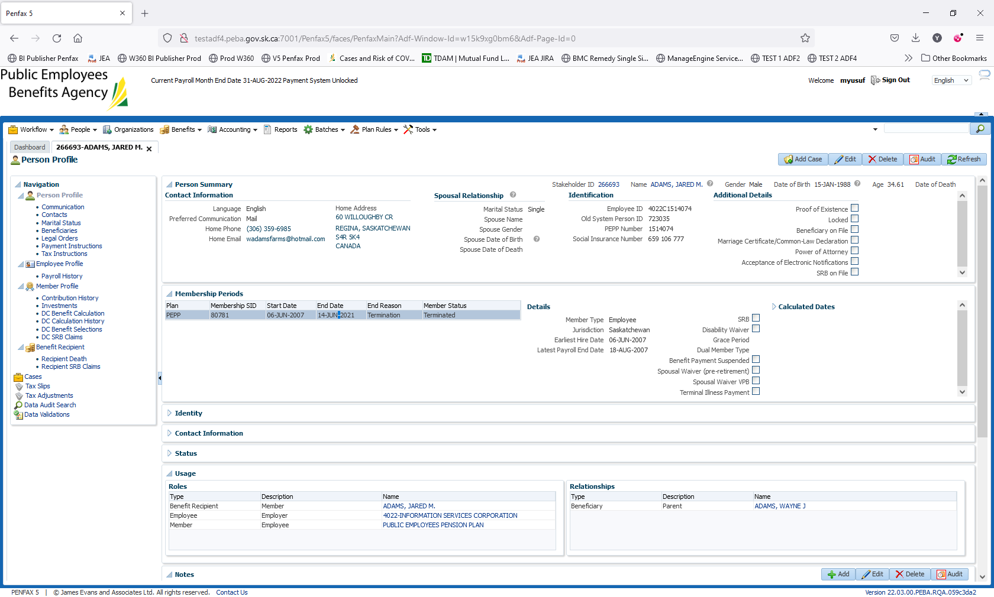

Click on Cases

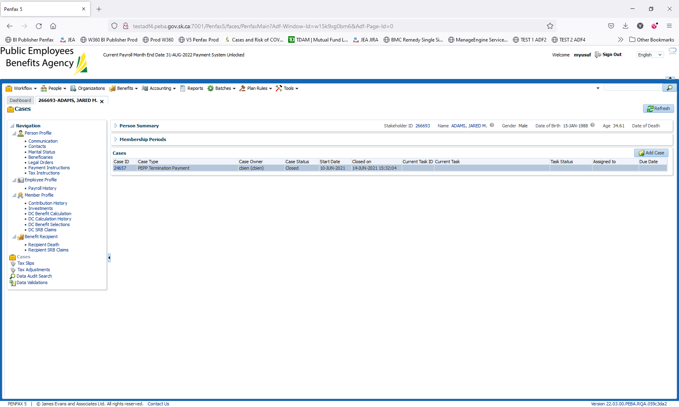

Click on Add Case

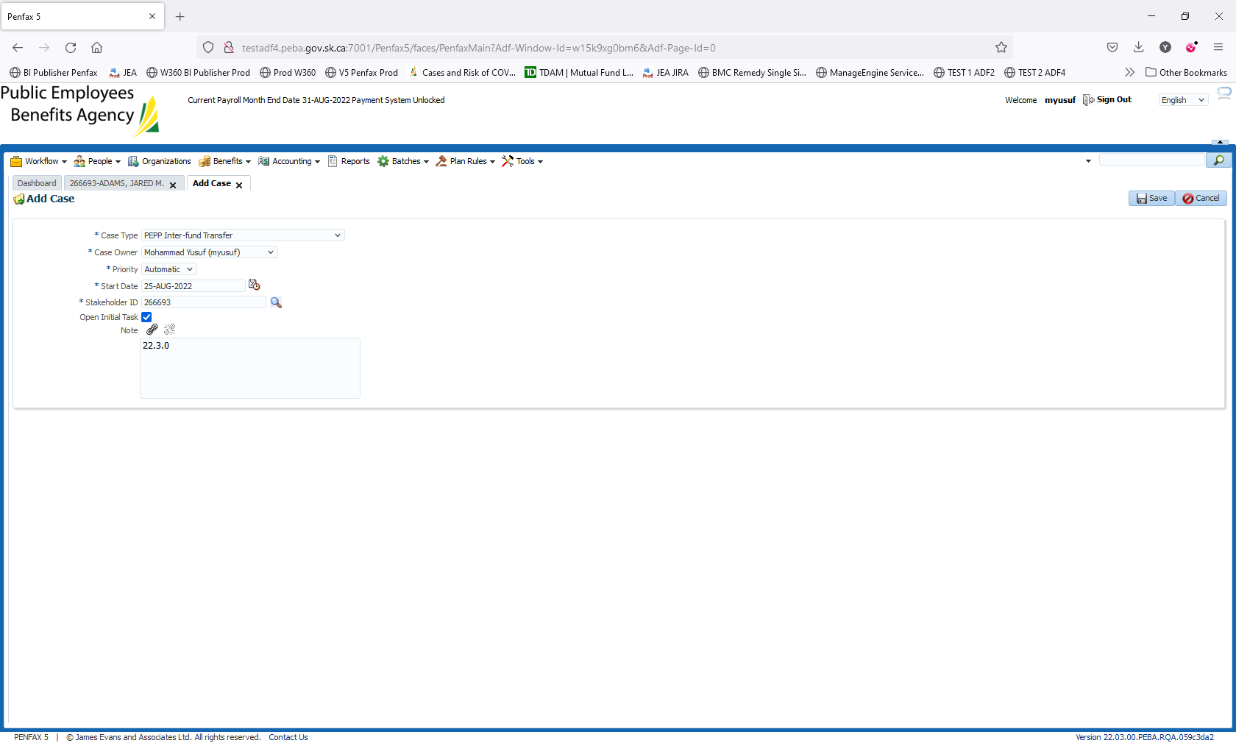

Click on Save. Case is created

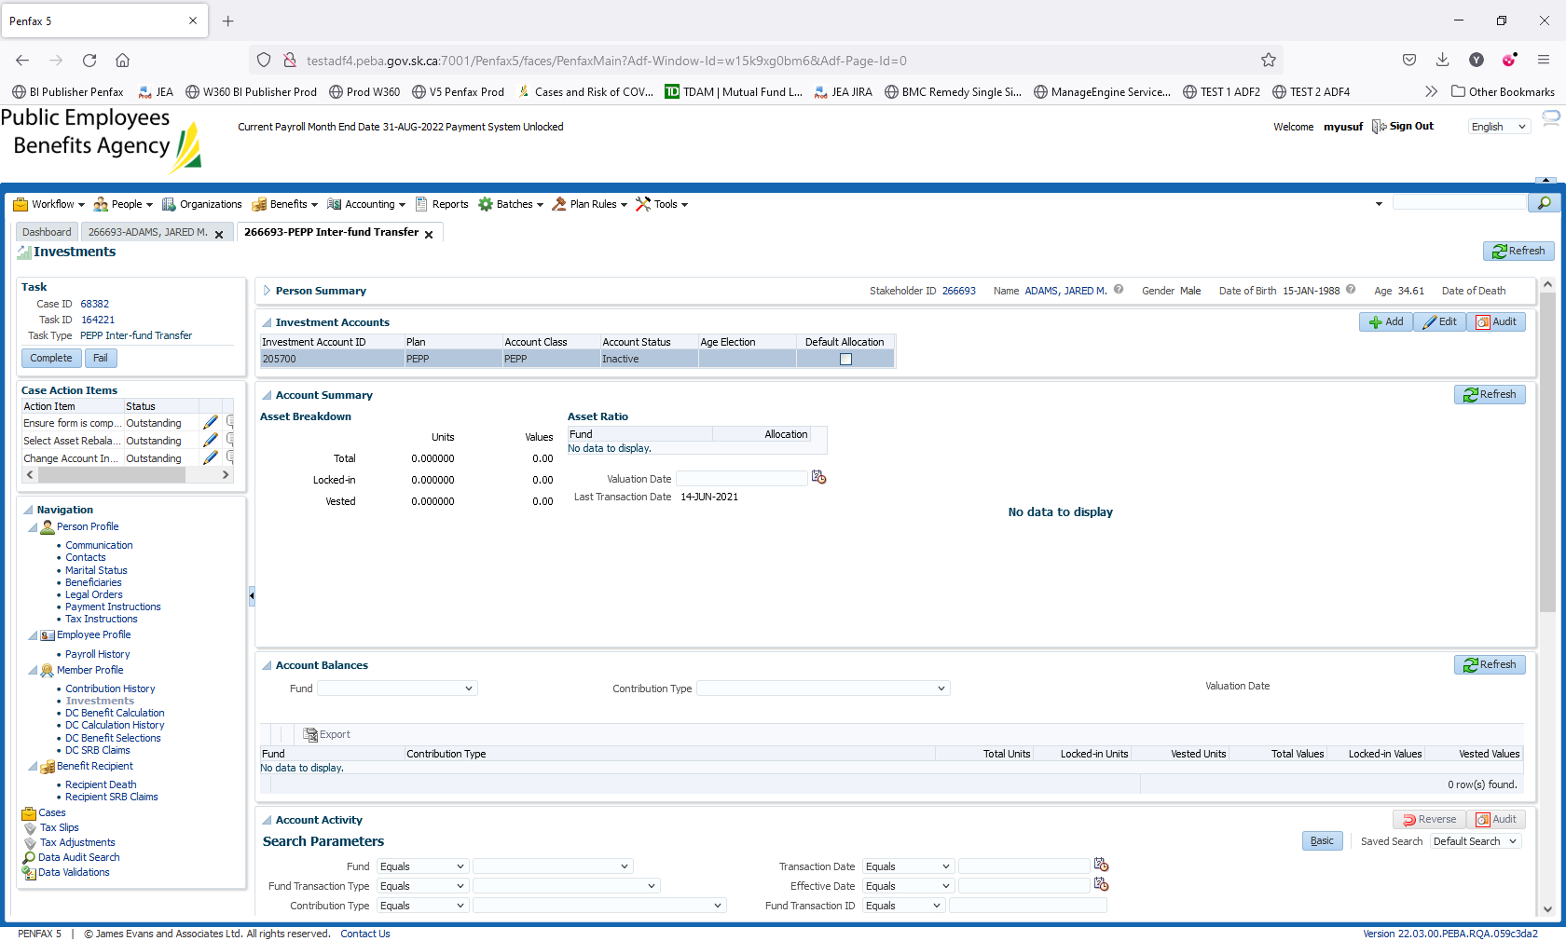

Mark the Case as Completed

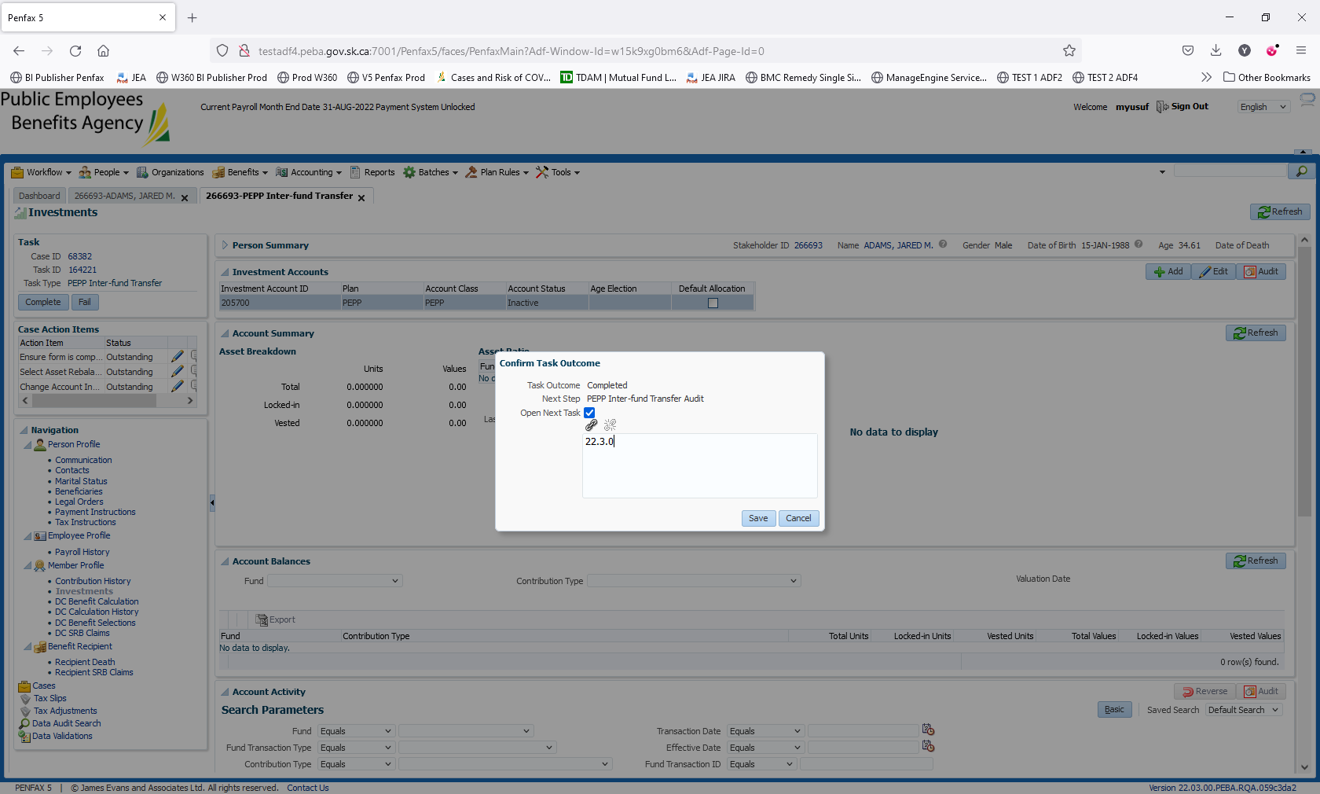

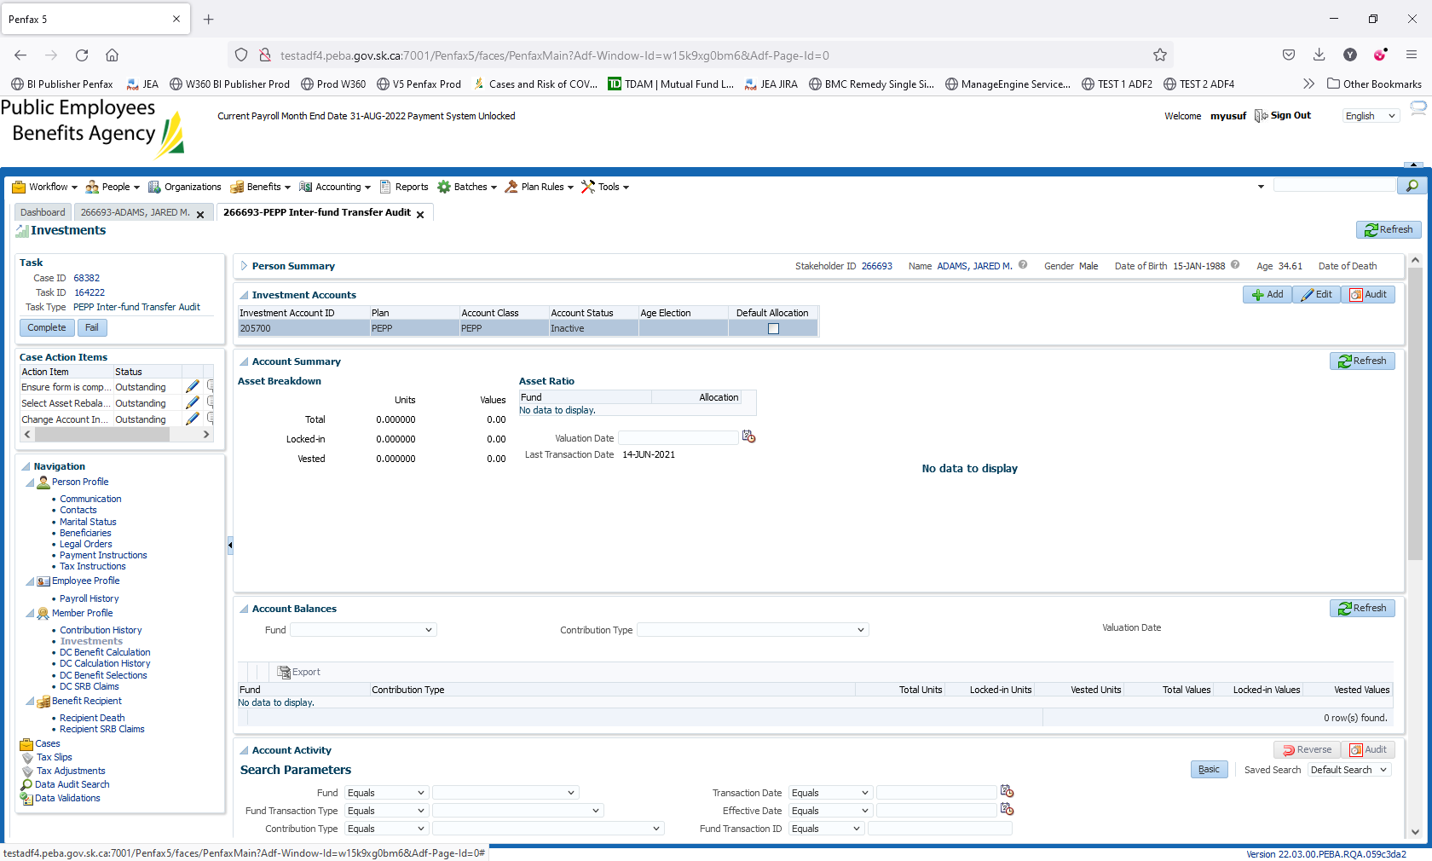

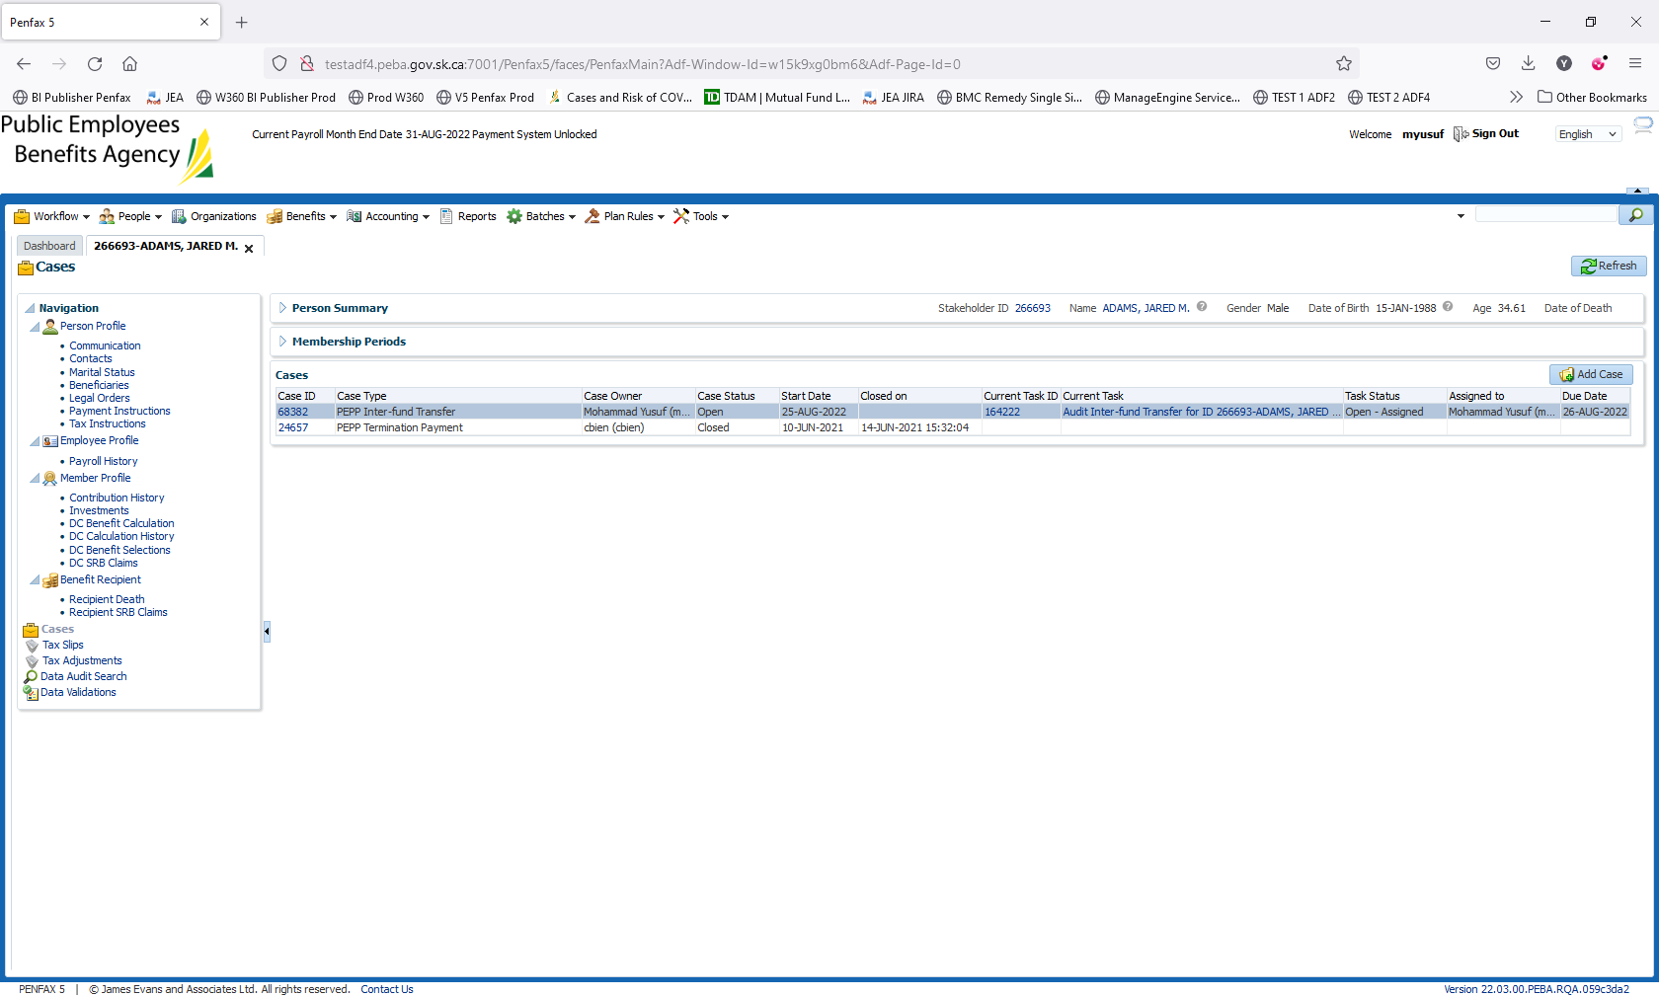

Go to Dashboard. Click on My Tasks

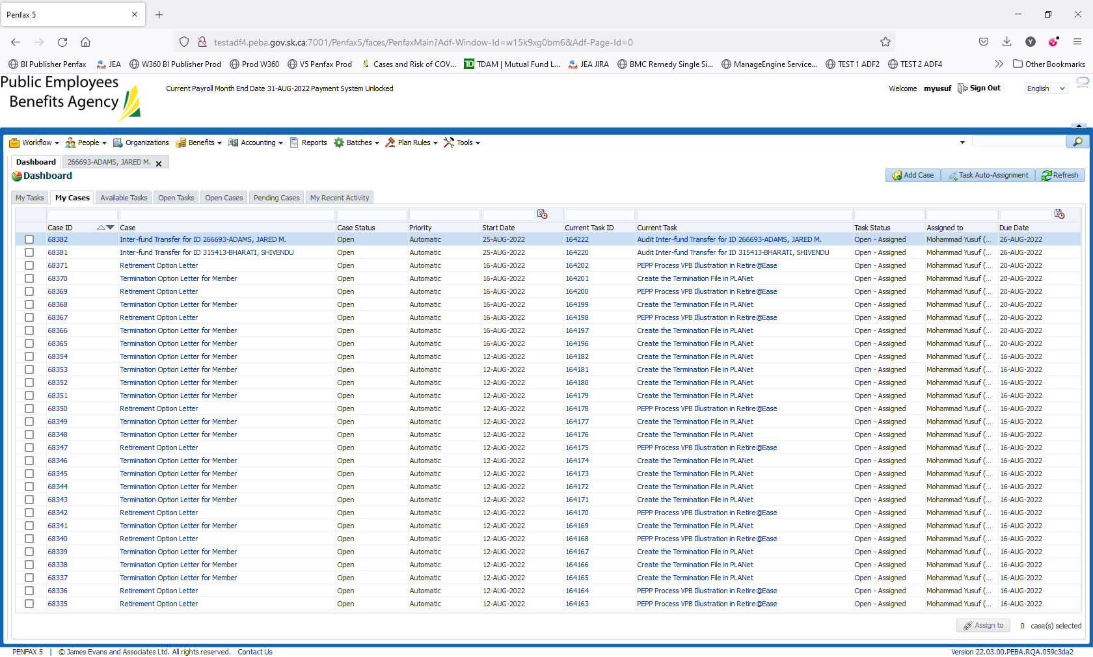

Click on The Task Id 164222

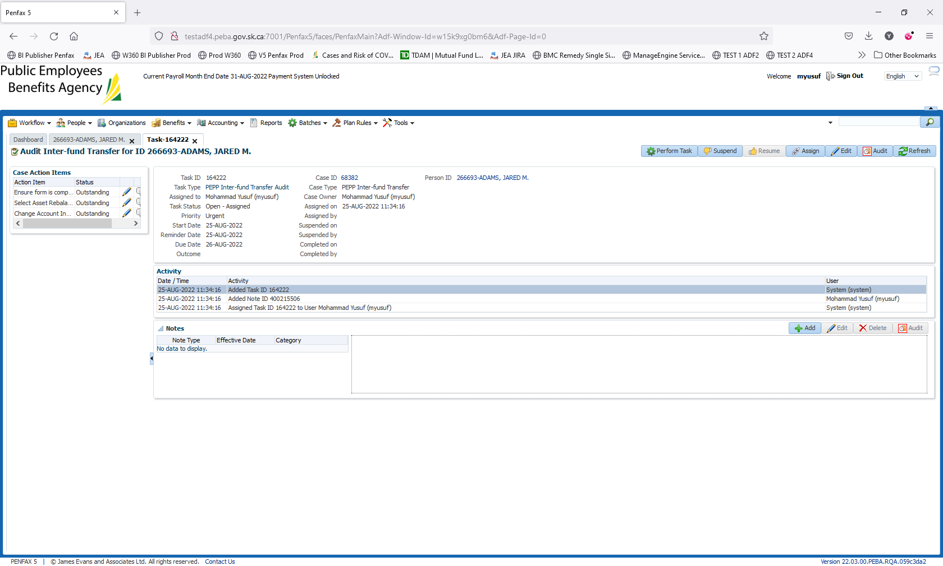

It is observed that the task status changes to on hold.